Assignment 2: The IT World

Team Profile

Team name:Stick Finger Dismissal

Personal information

Name: Xuyi Wu (Virgil)

Student number: s3733582

My name is Xuyi, you can also call me Virgil. I come from China, I used to serve in the army as an sergeant before I came here and majored in Info Tech. I love computer games and I’m very interested in programming. I hope one day I can develop my own game.

Name: Hui Li

Student number: s3642065

I come from China, so I am an international student in Rmit university. I have received 12 years of education in China. So Chinese is my first language, and English is my second language. Then, I will talk about my hobbies, computer is my favorite a thing, I like playing computer games, like watching movies, like surfing internet etc. Computer is a best thing for me. After that, playing basketball is my favorite outdoor sport, I like watching NBA. LeBron James is who I like famous NBA star.

Name: Basil Lilovac

Student number: s3786614

Name: Gong Jialiang (Datura)

Student Number: S3678537

This is Gong Jialiang. I'm from Southern China, Guangdong Province. I enjoy playing games, including ball-games and e games; hiking or driving out for a trip is also the hobbies of mine. For information technology, I have firstly heard, and tried, and now learning. The more I know about IT, the more I'm getting interested in it: a way to command a servant who never refuse you request, if you pay for electric fee. I got few IT experience and the first experience is about the tiny little bit of knowledge about different of languages.

Name: Junquan Chen

Student number: s3762081

I’m from Hangzhou where is located in the southeast of China. I’m studying a Bachelor of Information Technology at RMIT. I’m a kind of a rookie in the computer and IT area, this is my first time to study IT. I’ve never touched it before, computers used to be just entertainment for me. My favorite sport is basketball; I watch the NBA as well. Also, I play League of Legend and some video games on PS4.

Name : YuHao Tang

Student number: s3699311

I come from China, can speak Mandarin and English. This is the first semester at Rmit. I felt so excited and nervous about my university life. I like bake , I am willing to make desserts in my spare time, so I become a foodie slowly. However, I also like sports so much, like skateboarding and basketball. I skateboard to and from school almost every day.

Name: ZhenhuiHe (Herbert)

Student Number: S3670160

Email: s3670160@student.rmit.edu.au

my name is Zhenhui ,you can call me herbert, i am from south part of china and i'm a crazy liverpool fans ,before i come to RMIT, i was study bachelor of graphic design in china, i want to become a web developer.

Team Profile

Test outcome:

Xuyi Wu: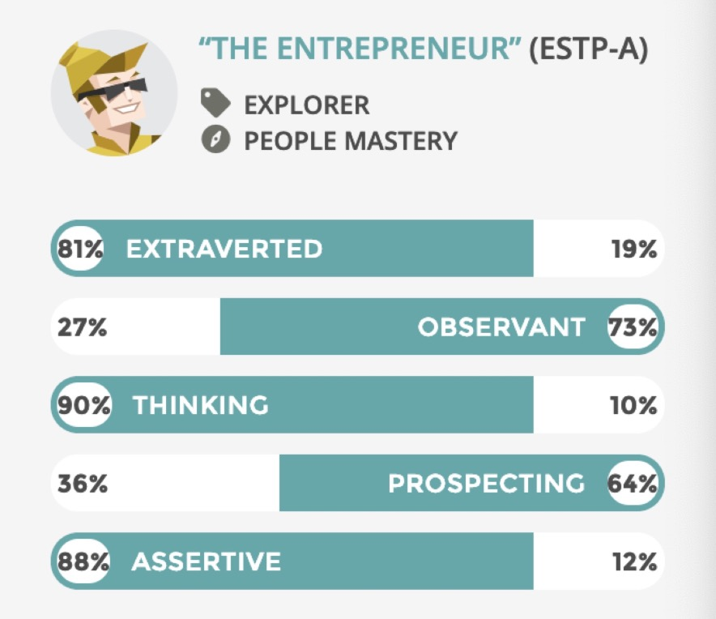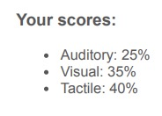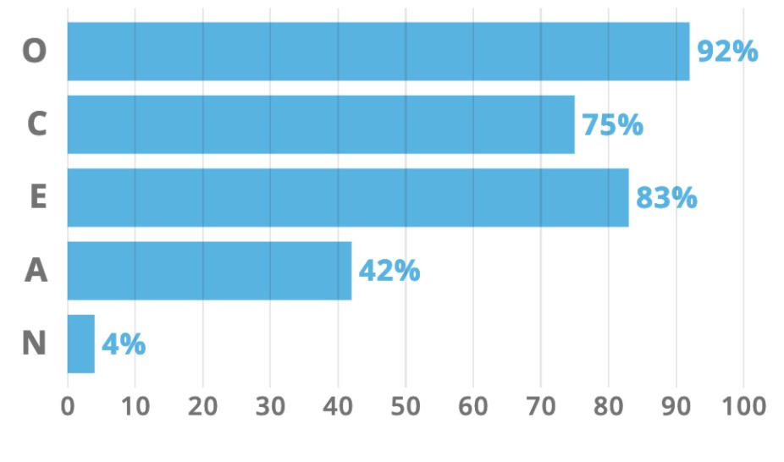

Hui Li: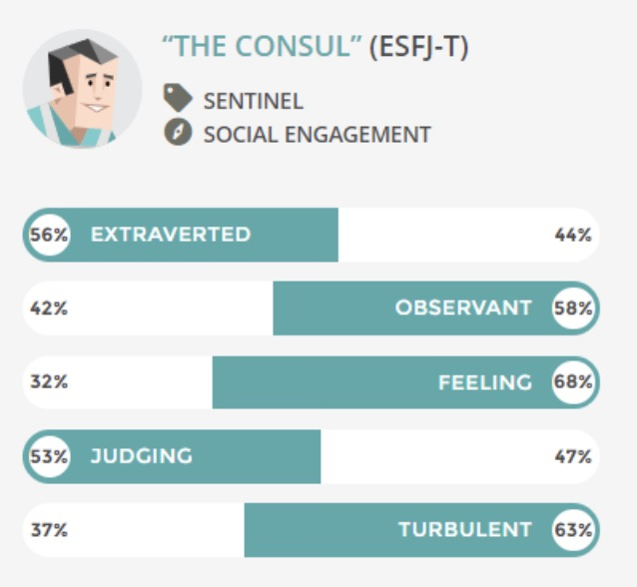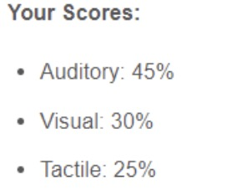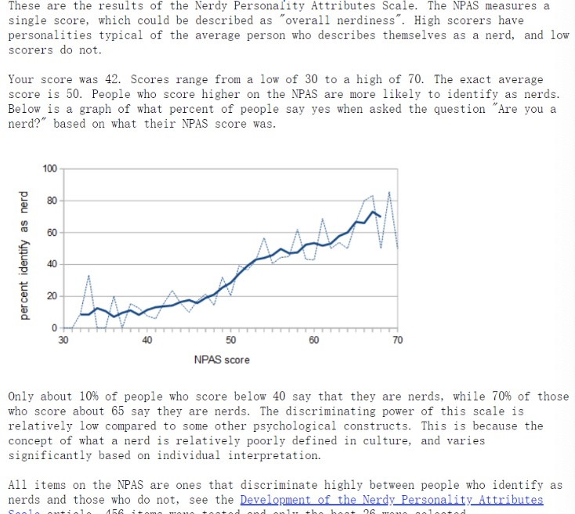

Basil Lilovac: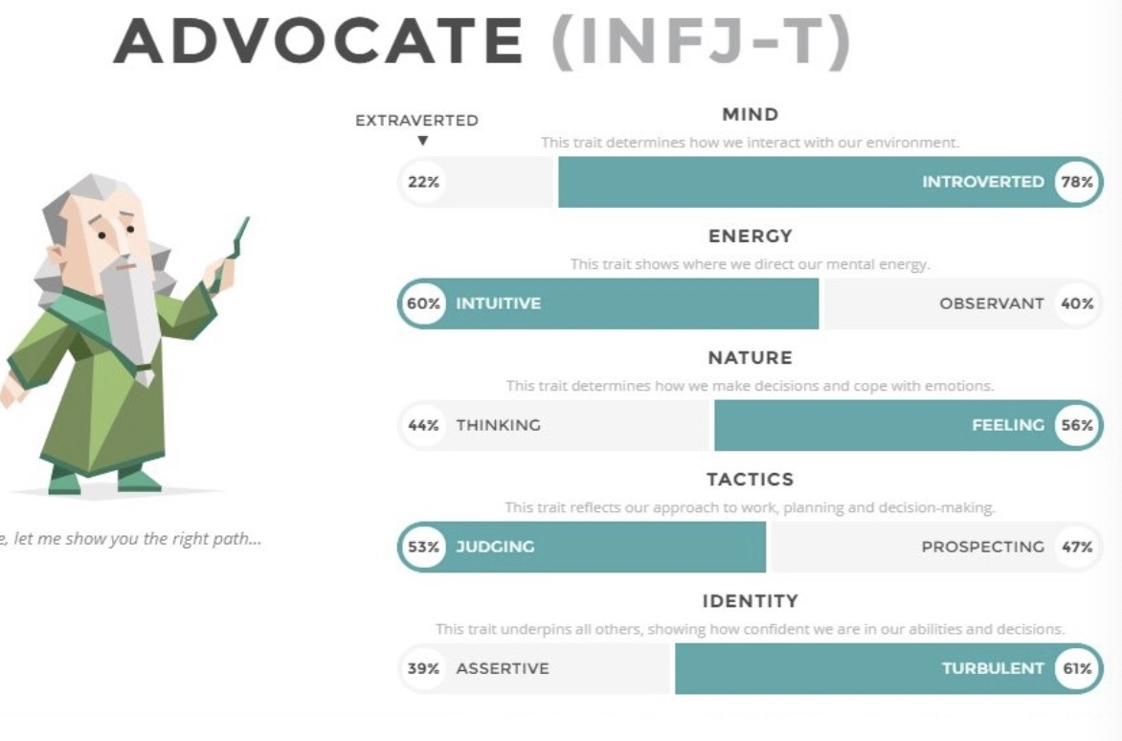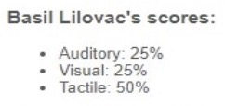

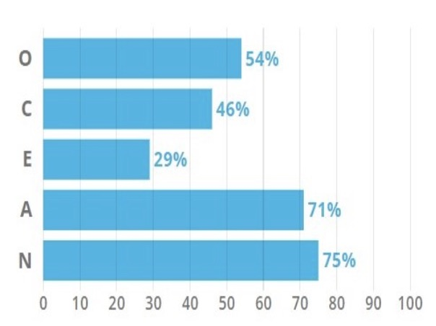

Zhenghui He: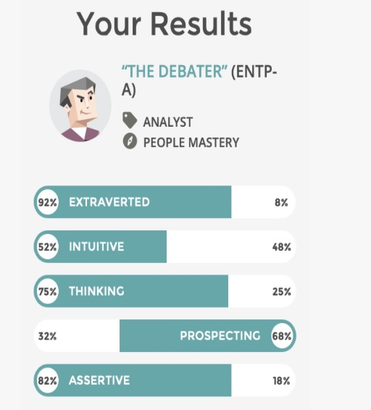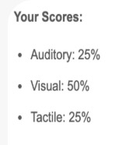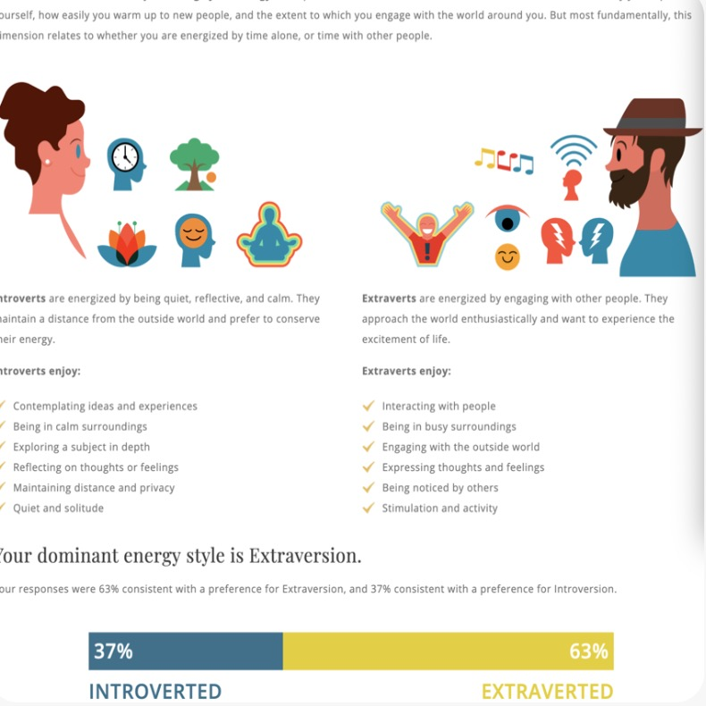

Junquan Chen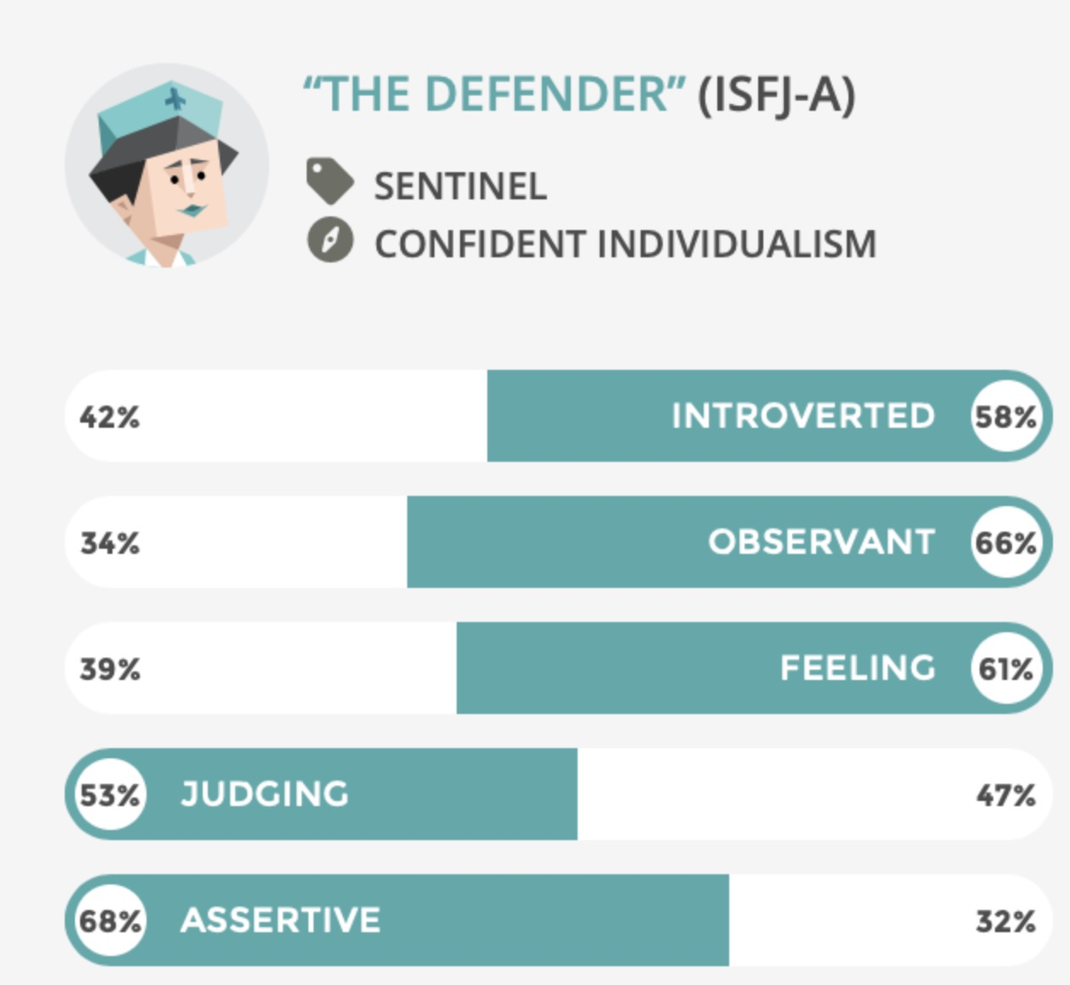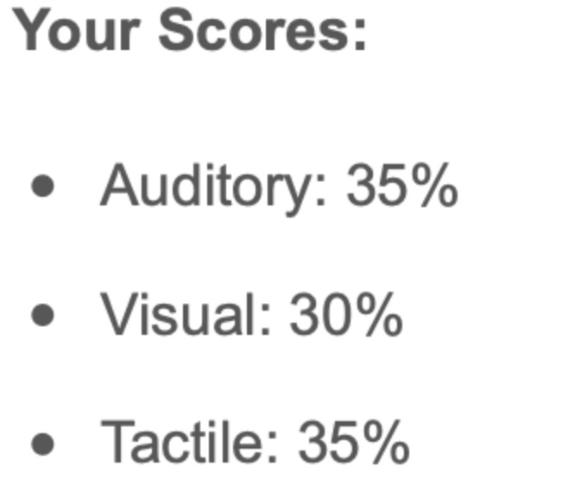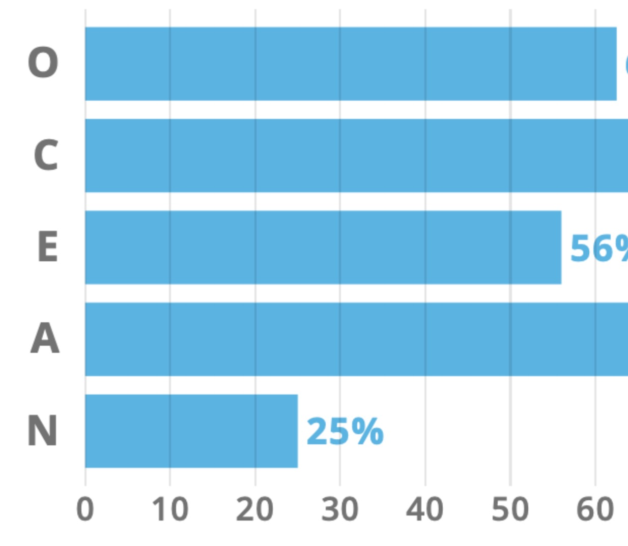

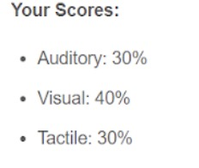

Yahoo Tang: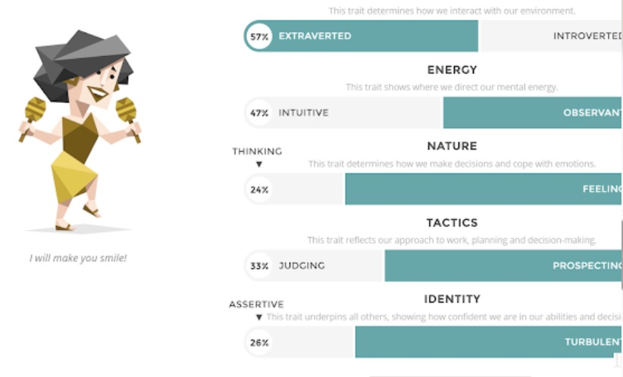

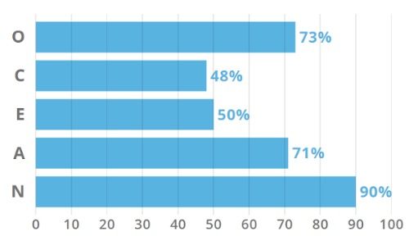

Jialiang Gong: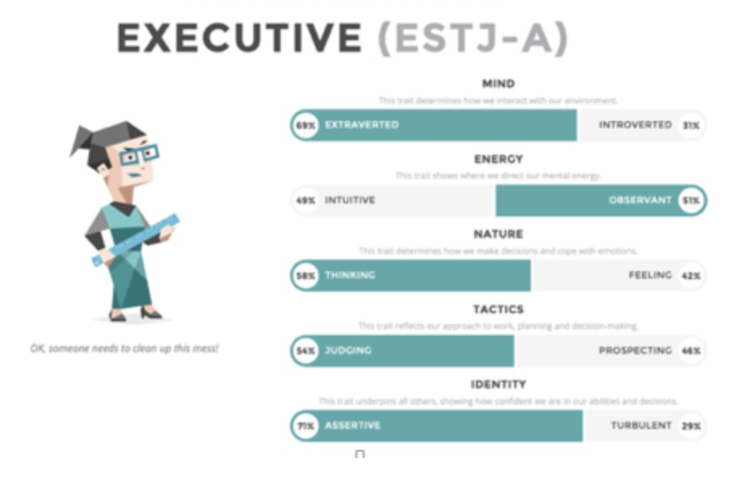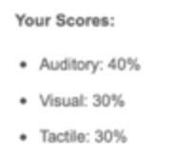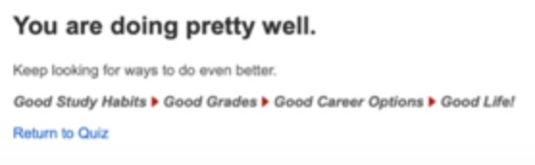

In this team, according to the information, Xuyi Wu’s Intuitive and logical thinking Indeed will be quite helpful and as an extraverted character who will not easily judging things, Xuyi Wu seems good to take responsibility on organization and co-ordination.

Basil Lilovic, according to the data, seems to be introverted but will have a strong ability to solve problems and creative enough to handle the complex works. What’s more, a plan will be very important for him, so it will be very helpful to have a detailed plan at the very beginning.

Hui Li is also seems good to take responsibility on works and will also be very organized. He will spare no effort to perform their duties and obligations and seems to be very reliable. He will also be a good choice for an important and phased task.

Zhenghui is exactly good at communicating and organizing the group, being observant is also good for him to work as a team-to-team communicator. It is believed that he will also adjust the team atmosphere when necessary.

Junquan Chen tend to be introverted and speechless but it will get better during the time. What’s more, he tends to be very responsible and kind which means he will finish his tasks on time and if possible, he will give a hand to other group members.

Yuhao Tang tends to be very careful and strategic and seems to be good at making decisions. He can find the problem from all angles which will be quite helpful in the team.

Gong Jialiang got an average evaluation. With a slightly higher evaluation on extraverted part and assertive-character, he seems a good member on communicating between members and help to make decisions. On the other hand, he is also good at helping making plans.

Ideal Jobs

All our ideal jobs are IT related and have a good salary. They all require the employee to work in a team and master at least one programming language, some of them also require the employee to have working experience.

However, although our Ideal Jobs are all IT related, they are in different specific areas like data consultant, SQL developer, software engineer, game developer, web developer and so on. Their working environment are different, some are in the office, some are in the studio. The computer language required at work will be different. For SQL developer, it will be SQL. For software engineer, it will be JS and for the HTML5 game developer, it will be HTML5. What’s more, the required tools will be different. For web developer, it requires some web framework and for programmer, it will be some programming tools.

Most of us plan to become a programmer after graduation but some of us are not interested in programming and want to develop in other directions like being a consultant or other positions which don’t need programming.

Industry Data

Xuyi Wu Game Developer - Unlisted

Hui Li Senior Software Engineer - Ranked #16

Basil Lilovac Business Analyst - Unlisted

Zhenhui He Front End Developer - Ranked #6

Junquan Chen Microsoft SQL Developer - Unlisted

Yahoo Tang Consultant - Unlisted

Jialiang Gong System programmer - Ranked #4

IT-specific skills

SQL - Ranked #1

SSIS(SQL tool)

SSRS(SQL tool)

SSAS (SQL tool)

Javascript - Ranked #2

VueJS(JavaScript framework)

JAVA - Ranked #3

Graphic Design - Ranked #10

C# - Ranked #12

Responsive designs(Website production) - Ranked #17

SEO(Website production) - Ranked #17

HTML5 - Unlisted

jQuery - Unlisted

CSS - Unlisted

SCSS - Unlisted

Photoshop - Unlisted

Flash - Unlisted

Adobe InDesign - Unlisted

PHP - Unlisted

Power BI - Unlisted

Angular - Unlisted

Confluence - Unlisted

JIRA - Unlisted

General skills​

Communication Skills - Ranked #1

Problem Solving - Ranked #2

Organisational Skills - Ranked #3

Writing - Ranked #4

Team Work - Ranked #5

Detail-Orientated - Ranked #8

Time management - Ranked #12

Analytical skill - Ranked #17

Self-propelled - Unlisted

Conduct interviews - Unlisted

The three highest ranked ​IT-specific skills​ which are not in required skill set

1.Microsoft Windows - Ranked #4

2.Project management - Ranked #5

3.SAP - Ranked #6

The three highest ranked ​general skills​ which are not in required skill set

1.Troubleshooting - Ranked #6

2.Planning - Ranked #7

3.Creativity - Ranked #9

**IT Work**

Regarding the interview with the IT Specialist, our group interviewed a programmer who has been working for ten years. He gave us some experience and some experience about his practice.

Q1. Please tell us about your IT work. What exactly do you do?

A1: programmers or programmers are mainly engaged in software requirements, development, testing, operation and maintenance, operations, QA and other work.Workforce management system-full stack programmer.

Q2. What other kinds of work do you have to do?

A2: Most of the time writing code, there is demand communication, single test, detailed design, etc.

Q3. Who are all the different people you interact with in your work? Please tell us about them.

A3: development is mainly for demand personnel, product personnel, testing, operation and maintenance, operating personnel, the above operators also interact with users and bosses, products also interact with user bosses, user bosses are not necessarily professionals, users are the general public, bosses It is an investor.

Q4. Please tell us about your interactions with other IT professionals.

A4: Product Owner-know about customer needs、discuss bussiness logic；Agile Coach-stand up meeting，story and bug assign；SQE-verify feature & bug；Other coders- code review，mobbing together，discussion， helping each other

Q5. What about your interactions with clients or investors?

A5: Teachnical Lead- helping tricky bug，refactor，best practices；Devops Engineer- monitoring build pipeline，eg. Build，CI、CD；SQE- test、verity bug & story deliver by programmer；Programmers in team-codeview， mobbing，discussion；Programmers in other teams- helping each other， technical discusstion，online meeting.

Q6. What aspects of your work do you spend most time on? Please tell us about these.

A6: most of the staff spend most of their time in the computer room and office, and the product or demand takes a lot of time to meet or draw.

Q7. Which aspects of your work do you find most challenging?

A7: this should be determined according to the work unit, sometimes the challenge is mainly from technological innovation, because the times are developing, technology is always updated, the only way to keep up with the times. There are also pressures from competitors to be forced to innovate. If they have been stagnant and do not progress, they will be defeated by competitors. Another important thing is the company's strategic innovation. If your own technology does not improve, you can't complete the company's work. After a long time, it will be eliminated by the company.

Q8. Can you share an example of the work you do that best captures the essence of the IT industry?

A8: Understanding business logic

Q9. Finally, do you have any good advice for us?

A9: This depends on the direction you choose, but one of the more important things is that you should learn the basics.

**IT Technologies**

Blockchain and cryptocurrencies

You may or may not have heard a lot of stories about Blockchain, and blockchain is like the development of the Internet in the 1990s, when, who knows what the Internet was?As long as the company is on the ".com "domain name, a rush. Until the bubble bursts; In those days, it was the "shovel sellers" who really got rich. Since then, the Internet after a decade of the downturn; After a few more periods, it eventually led to changes in various fields, causing social, economic and cultural innovations. The Internet solves the problem of ‘information’ asymmetry and delivers information. Blockchain solves the problem of "trust" and delivers ‘value’. Blockchain is a growing list of records, called blocks, which are linked using cryptography. Each block contains a cryptographic hash of the previous block, a time stamp, and transaction data (from https://en.wikipedia.org/wiki/Blockchain). A cryptocurrency is a digital asset designed to work as a medium of exchange that uses strong cryptography to secure financial transactions, control the creation of additional units, and verify the transfer of assets. Cryptocurrencies use decentralized control as opposed to centralized digital currency and central banking systems(from https://en.wikipedia.org/wiki/Cryptocurrency#Formal_definition ).To describe the role of blockchain in one sentence is "where there is a lack of trust, blockchain can play its role".It has three characteristics: decentralization, anonymity and information tampering. So what it can do, at the end of the day, is it can solve the trust problem. To take A realistic example, I bet with A on the NBA championship, I said warriors, A said Cavaliers.But I doubt A's bet. I'm afraid he'll walk away if he loses. Did not expect A bite back, but also suspect that my gambling is not good, it is simply ridiculous! Then we need a trusted third party to act as a notary. We can each give twenty dollars to a notary whom we can trust for safekeeping. If the warriors win by then, $40 is mine. If the Cavaliers win, $40 goes to A.Final final series ended eventually, notary rolled a huge sum of money 40 yuan ran. The solution to this problem is to write an intelligent contract.

The contract code looks like this:

Result =NBA official website api.get (‘ finals ‘)

If (knight wins)

Pay 40 to A

The else

Pay 40 to B

We put the code into the blockchain and execute it, and the blockchain is like an untrusted trust that just executes the code. When the game comes out when the code is executed, nobody gets paid, and we all get rid of the mistrust. Blockchain technology should give birth to cryptocurrency. Blockchain is the technical basis, and digital assets are the incentive mechanism based on blockchain. The application of blockchain technology needs the incentive of digital assets, and the development of digital assets must also rely on the breakthrough and application of blockchain technology. Blockchain and cryptocurrency are like wood and wood products, and bitcoin is by far the most successful example of cryptocurrency. At the same time, bitcoin also is the most successful application of blockchain so far, because it can be transmitted through the Internet in an environment of zero trusts. Without bitcoin, even now, it is not easy for an Australian and an American to exchange money with each other without a centralized bank. The most practical application of blockchain at this stage is speculation/finance/gaming/gambling. For the application of the physical industry, it is still uncertain, because the development of blockchain may be rapid, in the near three years it may be applied in property registration/justice and anti-counterfeiting/food traceability/medical education and so on. The development of blockchain needs to be based on the trust between people. The best time for the development of blockchain is to achieve complete trust, which is almost impossible now. In addition, policy support between different countries is needed for the blockchain to have an environment for development. The great thing about blockchain is that it's never corrupt, it's completely transparent, and it can bypass any kind of censorship. In other words, blockchain makes people work more efficiently with each other, but it's built on mutual trust. Cryptocurrency is a product of blockchain, it's a futuristic currency, and at the moment, most people are questioning its security and its future. It's just a digital currency, and cryptocurrency is hard to counterfeit because it USES cryptography to ensure security. These are the decentralized systems of blockchain technology. None of this is issued by any central government, which in theory allows it to operate without any interference from anyone, including the government. Cryptocurrencies are more like a currency of the future. It can provide equal services for different people, embodying the fairness of cryptocurrency.

If blockchain can be developed, it will be closely related to our life. The art industry: artists can use blockchain technology to claim ownership and issue Numbers. It also includes a marketplace where artists can buy and sell through their website without any intermediary services. The legal profession: traditional fair play will be a thing of the past, with all academic credentials placed on the blockchain, redefining how diplomas and student certificates are handled and used. Development industry: 'token' assets, like cryptocurrencies, can be set in various states and types to trade among wallet holders. Real estate industry: it can make the whole industrial chain process more modern and solve all kinds of problems faced by everyone involved in the real estate industry.Internet of things industry: it can greatly reduce the operating cost of the Internet of things. At present, the Internet of things basically adopts a centralized architecture. Blockchain technology provides point-to-point direct interconnection management for the Internet of things, and various instructions are transmitted through the blockchain, which is more efficient. The application of blockchain represents the transparency of everything. Just like the relevant certificates in the legal industry mentioned above, whether you want to determine whether it is a fake certificate, or whether the lawyer really has the qualification, blockchain can make it transparent. The other is peer-to-peer transactions, like in the art industry, between artists or between buyers. Blockchain can make it safer and more flexible. You don't have to worry about buying fake goods anymore, or artists worry about the buyer's money not getting paid. Blockchain technology makes all walks of life more convenient, it is a future technology, wood to have certain limitations.

If blockchain is widely used in the future, it will be just like the Internet. People just need to enjoy the convenience and efficiency it brings to us. For me personally, IT will be closely related to my life, because I majored in IT and I will also be engaged in related work in the future. I will be exposed to the Internet of things. Blockchain can make the Internet of things more efficient, which is an innovative technology and the whole industry may be greatly changed. In addition, with the development of the network, all kinds of data need to be protected. The protection of personal data is very difficult. For example, SONY and Yahoo have been attacked countless times by hackers. A large number of personal accounts have been leaked, which represents a serious defect of the system. There are only public and private keys in the transaction, which ensures the security of the transaction and enables me to trade with confidence. For everyone, it improves the quality of life, makes the work between people more trust, more efficient.

Autonomous Vehicles

Nowadays, the cars became more and more advanced. There are more and more electronic screens in the car and the touch screen as well. Also,the emergence of battery cars shows the rapid development of science and technology. However, since the battery cars and technology developed, people start to consider how to “eliminate” the driver. This developmental process is inevitable, autonomous driving has gone from “maybe” to “absolutely possible” finally to “inevitable”. Autonomous vehicles are also called self-driving cars, as the name implies, this kind of car is driven by computers. This kind of scene usually happens in science fiction movies, but there have been many successful cases in our real life, such as Tesla and NIO. Future is coming. More and more car companies are starting to research technologies which related to autonomous driving. Self-driving is becoming a trend. For example, companies like Tesla, Uber and even old mainstays like Ford, they all have several prototypes in the field (self-driving technologies). Some people say future is already here because there are some cars on the market that can achieve self-driving even just in some certain situations. For instance, the cars which belong to Tesla are able to drive for hundreds of miles in the highway and stay in the lane which is quite hard for new driver. Also, as we all know, fatigue driving, traffic violations and other phenomena occur from time to time in the highway. But there are no traffic lights, no obstacles and the car is fast where is a good place for self-driving. Self-driving cars don't change lanes randomly so it can effectively reduce the probability of traffic accidents and avoid the problem of driver fatigue as well. What’s more, Unmanned delivery vehicles have been practiced in daily life. These cars are always found in safe, low speed and low risk environments such as schools, residential areas and industrial parks. The reasons why the unmanned delivery car could be on the road are those lines are very uniform and the maps are accurate. In addition, some companies (Uber)are already using driverless taxis. It is very convenient which helps the company to effectively eliminate a large number of labour cost, and it provide operating profits and reduce passenger travel costs. At present, the functions and modes of autonomous driving are relatively single, a lot of functions can only be implemented on roads with simple road conditions. In the future, after 3 years, the levels of self-driving car will be able to up to level 5 which is the top level of autonomous driving. In level 5, the steering wheel became an available option for the car which means an autonomous vehicle can drive on the road without a steering wheel. Also, driverless buses will be achieved as a trend to change the public transportation. Each bus has a fixed route and fixed time.Dedicated bus lanes can greatly increase safety. What’s more, the number of car parks will decrease and the place will be used to rebuild more useful facilities. However, the laws related to autonomous driving will be determined and implemented. The knowledge about autonomous driving will also be popularized to let people know that it is safe to trust technology. Talking about the technologies that made autonomous driving become true, in my opinion, there are 4 main technologies. First of all, artificial intelligent is significant in self-driving. As a driver, the computer also need to learn how to drive and recognise the sign on the road. Also, the cloud is important as well. The reasons why AI can keep learning is because cloud. The cloud is continuously accumulating training data.The more instances of driving that can be stored in the cloud, the better to train self-driving cars to navigate public roads. What’s more, the accurate map and GPS in cars system are the indispensable reasons why the car can arrive at the destination accurately. In addition, radar is like human eyes to identify obstacles and other vehicles near the car, to avoid traffic accidents in time.

When the technology of autonomous driving becomes very mature, it will lead to a bad situation for driver. They will face the possibility of losing their jobs. The advent of driverless cars has made car-sharing be possible. It will create a new business model.The car market will change dramatically after the popularization of driverless cars. When people need a car, they can take out their smart phones and call a car to take them to their destination. Therefore, private cars will become unnecessary and people will gradually not buy cars.The traditional automakers may be forced to build self-driving cars or shut down because they can't handle the pressure of low profits. Also, self-driving cars may make some professions disappear, such as Taxi driver and traffic police. People can spend less money to call an autonomous car which is safer and cheaper than taxi. Self-driving cars have precise positioning and navigation systems that will automatically avoid congested roads. So there is less need for traffic police to maintain traffic conditions. However, self-driving cars can greatly reduce the probability of traffic accidents. As a result, about 1.25 million people die each year in traffic accidents around the world. People are not machines, so there are a lot of external factors that can cause people to be distracted while driving. For example, people cannot keep driving for more than 4 hours, it is easy to lead to a fatigue driving. The most likely cause of traffic accidents is driver fatigue driving. When driver felt tired, they cannot respond instantly when special occasion happens, let alone making right reactions. But autonomous car is a good way to avoid this problem. Self-driving cars have the power to react dangerous situation, it can immediately start breaking when the car senses risk. Autonomous vehicle has extraordinary senses because of radar and camera.

In my point of view, I got the full licence so I know how to drive and I think I can drive safe. I've heard some information about self-driving cars andsome short video. When I first heard about autonomous driving I felt amazing. I’m imaging the scene where the driver is not seated and the steering wheel is turning by itself or the driver seat in front of the steering wheel who is reading book or sleeping, but the car is still moving safely. I'm a new driver so I still have some interest in driving, so I’m not going to use this technology very often. But self-driving is a good choice when I’m driving on the highway and landscape. When people who is driving on the highway cannot distract, because they need to keep the car stay in the lane and pay attention to the speed. People are easy to be tired when they are focused, especially for driving a long time. Also, when people drive through scenic areas,the beautiful scenery will attract them to stop and look at it for a while. But it will cause traffic jams easily. Therefore, self-driving can help for this situation. User can set the speed and route,so they can enjoy the scenery without causing trouble to the traffic. That’s the reasons why I will try autonomous driving. In addition, as far as I know, self-driving cars are generally electronic cars,this can well reduce carbon dioxide emissions and further improve the environment, also slow down the rate of global warming. I think the last generation will have a hard time to accept self-driving cars. Young people are easy to accept new technologies. So I think the knowledge about self-driving needs to be popularized.

**Project ideas**

Simulated driving learning system

The simulated driving learning system is based on artificial intelligence developed by software that allows novice drivers to improve their driving skills. There are many simulated driving systems on the market, but they only allow the driver to learn basic driving knowledge. Many drivers experience unexpected situations while driving. Sometimes it is difficult to make the right decision because they have not experienced it. The situation has already occurred and this subconscious behavior may lead to more serious losses.

Car accidents occur every day around the world, but many car accidents can be avoided. The simulated driving learning system can be updated into the learning system by collecting emergency and accidents from drivers around the world. At the beginning of the exercise, the system will simulate the sudden situation of the road condition according to the driver's driving habits, showing the driver's poor driving behavior and how to better cope with such accidents.

Most of the car accidents are caused by the driver's misjudgment. A small mistake is likely to cause a fatal injury. Panic takes up the driver's brain to make a wrong judgment, but when people have encountered the same situation, make the behavior of misjudgment is relatively reduced. When an emergency occurs, the driver uses the coping method learned in the simulated driving learning system in reality, which may have a high probability of reducing the accident or reducing the loss caused by the accident.

In addition, this simulated driving learning system can also simulate different types of vehicles. The collected road conditions are adjusted according to the combination of vehicles selected by the trainees. Of course, heavy-duty vehicle drivers such as trucks can also use this system to improve their driving level. Accidents in heavy vehicles are often not caused by vehicle failures because the driver is not aware of the impact of the weight of the truck on the driving.

Of course, this idea sounds like a real driving game, but applying it to a part of forced driving learning will change the bad driving habits of many people, giving them the most profound experience, if people can pass the game. To improve driving levels and reduce losses and accidents, I believe many people will be happy to see this system applied to life.

Building such a simulated driving learning system may not be easy, and many techniques need to be applied, such as collecting sudden road conditions around the world and collecting car data, as well as establishing a more realistic driving scene for the driver experience, which may be more advanced. 3D modeling. The hardest part is how artificial intelligence makes the best judgment based on road conditions and vehicle information. Another question about human nature may need to be solved manually: When the situation occurs, does the driver choose to protect his or her life or protect the lives of others? Many people think that protecting more lives is the first choice, but when things happen, I believe most drivers will choose to protect their lives. This is the problem that the system needs to solve most.

````````

Feedback-All

Group Reflection-All